Virex II 256 by Diversey Effective against Human Coronavirus

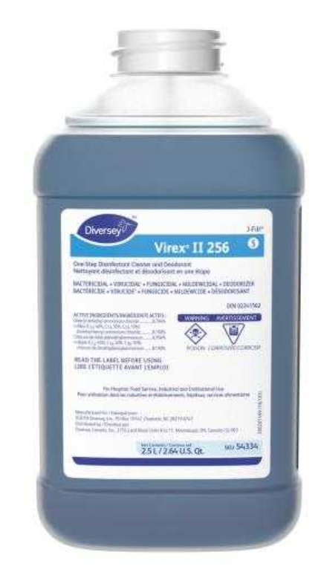

EPA REG. NO. 70627-24

Disinfection Dilution: Dilution 1:256 (0.5 ounce per gallon of water)

Directions for disinfection: This product can be applied by mop, sponge, cloth, disposable cloth, disposable wipe, paper towel, microfiber, (hand
pump) coarse trigger sprayer, auto-scrubber or foam gun (device). Change cloth, sponges (wipes) or towels frequently to avoid re-deposition of soil.

Contact Time: Treated surfaces must remain wet for 10 minutes.

Additional Information:
https://www3.epa.gov/pesticides/chem_search/ppls/070627-00024-20111216.pdf

