Table Tent Card Template



Edit the table tent card on the upper right of the next page. This will update the other cards in the template automatically.

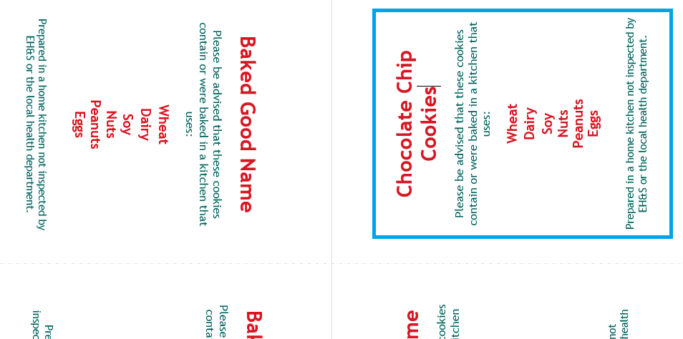

|  |  |
| --- | --- |
| Doughnut type Name Please be advised that these cookies contain or were baked in a kitchen that uses: WheatDairySoy Nuts Peanuts EggsPrepared in a home kitchen not inspected by EH&S or the local health department. | Doughnut type Name Please be advised that these cookies contain or were baked in a kitchen that uses: WheatDairySoy Nuts Peanuts EggsPrepared in a home kitchen not inspected by EH&S or the local health department. |
| Doughnut type Name Please be advised that these cookies contain or were baked in a kitchen that uses: WheatDairySoy Nuts Peanuts EggsPrepared in a home kitchen not inspected by EH&S or the local health department. | Doughnut type Name Please be advised that these cookies contain or were baked in a kitchen that uses: WheatDairySoy Nuts Peanuts EggsPrepared in a home kitchen not inspected by EH&S or the local health department. |